I need to create one Sales dashboard for my company . design dashboard using flask and each task need to be in separate api, now design the backend later we will discuss on frontend.
The below detailed documentation on tasks, and everything.
So kindly go through all points.

CREATE TABLE `billing_data` (
`Billing_Doc` varchar(50) DEFAULT NULL,
`Billing_Type` varchar(50) DEFAULT NULL,
`Curr` varchar(5) DEFAULT NULL,
`Sales_Org` varchar(10) DEFAULT NULL,
`Sales_Org_Text` varchar(30) DEFAULT NULL,
`Dist_Channel` varchar(10) DEFAULT NULL,
`Dist_Channel_TEXT` varchar(50) DEFAULT NULL,
`SHIP_COND` varchar(25) DEFAULT NULL,
`Inco1` varchar(75) DEFAULT NULL,
`Inco2` varchar(75) DEFAULT NULL,
`Payment_Terms` varchar(50) DEFAULT NULL,
`Unit` varchar(10) DEFAULT NULL,
`Created_By` varchar(50) DEFAULT NULL,
`Billing_Date` date DEFAULT NULL,
`Billing_Time` varchar(20) DEFAULT NULL,
`Customer` varchar(100) DEFAULT NULL,
`Name` varchar(100) DEFAULT NULL,
`Division` varchar(10) DEFAULT NULL,
`Division_Name` varchar(50) DEFAULT NULL,
`Sales_office_Cd` varchar(20) DEFAULT NULL,
`Sales_office` varchar(50) DEFAULT NULL,
`Sales_Region` varchar(10) DEFAULT NULL,
`Sales_Region_Name` varchar(50) DEFAULT NULL,
`Purchase_Order` varchar(75) DEFAULT NULL,
`Billing_Qty` int(11) DEFAULT NULL,
`UOM` varchar(10) DEFAULT NULL,
`Cond_Num` varchar(20) DEFAULT NULL,
`Tax_of_the_item` decimal(10,2) DEFAULT NULL,
`Net_Value` decimal(11,2) DEFAULT NULL,
`Gross_Value` decimal(11,2) DEFAULT NULL,
`Order_Number` int(11) DEFAULT NULL,
`Item` varchar(10) DEFAULT NULL,
`Material_Code` varchar(20) DEFAULT NULL,
`Description` varchar(500) DEFAULT NULL,
`Prod_hierarchy` varchar(20) DEFAULT NULL,
`VTEXT1` varchar(500) DEFAULT NULL,
`VTEXT2` varchar(200) DEFAULT NULL,
`VTEXT3` varchar(200) DEFAULT NULL,
`VTEXT4` varchar(500) DEFAULT NULL,
`Shipping_point` varchar(50) DEFAULT NULL,
`Store_Loc` varchar(50) DEFAULT NULL,
`Plant` varchar(50) DEFAULT NULL,
`Profit_Center` varchar(40) DEFAULT NULL,
`Prod` varchar(100) DEFAULT NULL,
`SRLNO` varchar(10) DEFAULT NULL,
`Exchange_Rate` int(11) DEFAULT NULL,
`fin_year` varchar(20) DEFAULT NULL,
`eWay_Billno` varchar(50) DEFAULT NULL,
`eWay_Billdate` date DEFAULT NULL,
`LR_No` varchar(50) DEFAULT NULL,
`LR_Date` date DEFAULT NULL,
`Transporter_Name` varchar(100) DEFAULT NULL,
`Vehicle_No` varchar(30) DEFAULT NULL
)

These are the columns of Billing Data

CREATE TABLE `billing_target` (
`Sales_office` varchar(50) DEFAULT NULL,
`Sales_Region_Name` varchar(50) DEFAULT NULL,
`Product` varchar(100) DEFAULT NULL,
`Unit` varchar(20) DEFAULT NULL,
`Target` decimal(10,2) DEFAULT NULL,
`fin_year` varchar(20) DEFAULT NULL
)

These are the columns of Billing Target.
I need a Main filters like Financial Year, Month, Region, Sales Office, Products.
In frontend I may apply multiple selections in filter so kindly note on this when creating parameters.
For Financial Year consider column fin_year( data like 2025-2026), For month get the month from column Billing_Date, for Region consider column Sales_Region_Name
for sales_office consider Sales_office for products, consider column Prod from billing_data, and Product from Billing_Target.
Here for Products, we have conditions
product list from billing_target product list from billing_data
HV MOTORS HV MOTORS
RRM RRM
DC MACHINES DC MACHINES
HV GENERATORS HV GENERATORS
LV MOTORS (NS) LV MOTORS
LV MOTORS (S) (To differentiate LVM(NS) and LVM(S), consider plant column in billing_data, if Plant = 'AC02' THEN 'LV MOTORS (NS)' AND Plant = 'AC25' THEN 'LV MOTORS (S)')
EVM EVM
LV GENERATORS LV GENERATORS
TRANSFORMERS MYSORE TRANSFORMERS MYSORE
SWITCHGEARS To get the (switchgears WHEN Prod = 'TRANSFORMERS MYSORE' AND VTEXT1='Switchgear' THEN 'SWITCHGEARS' else 'TRANSFORMERS MYSORE')
TRANSFORMERS PUNE TRANSFORMERS PUNE
DG SETS DG SETS
SPARES & SERVICE SPARES & SERVICE

For Quarters (Q1 (April, May, June), Q2(July ,August, September), Q3(October,November,December), Q4(January, February, March).
These are the very important to match up the targets and sales data, so kindly consider it very important.
The next is KPIS
Overall Sales (consider Net_Value Column), Billed_Quantity (Consider Billing_Qty) Invoices Raised (consider Billing_Doc) Customers Billed (Consider Customer)

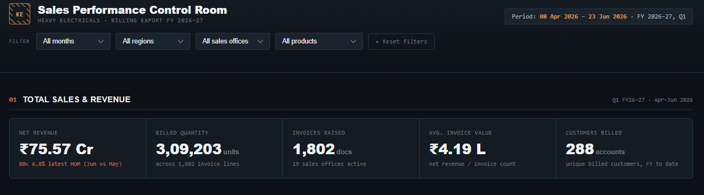

These are the graphs, I need,
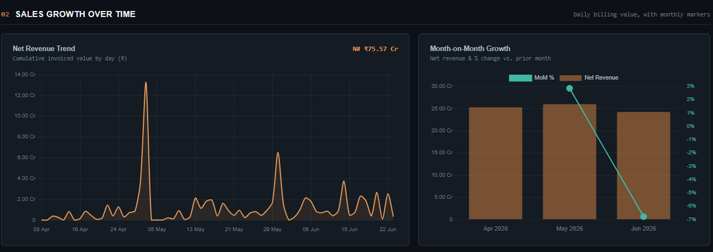

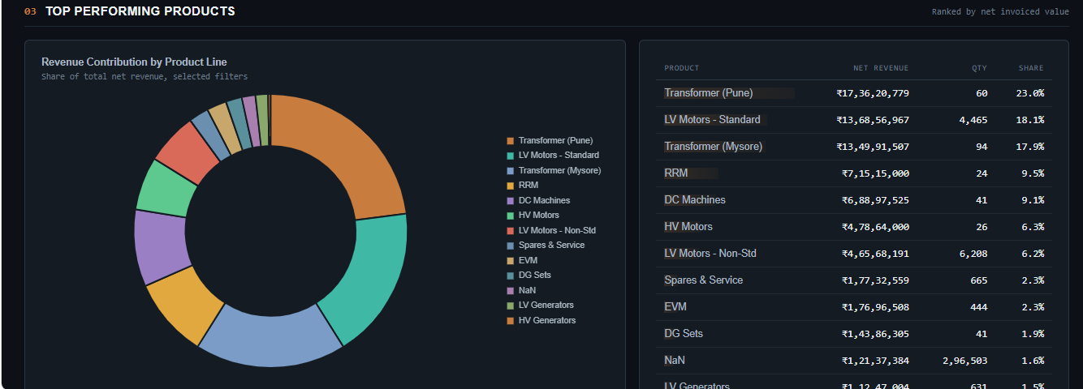

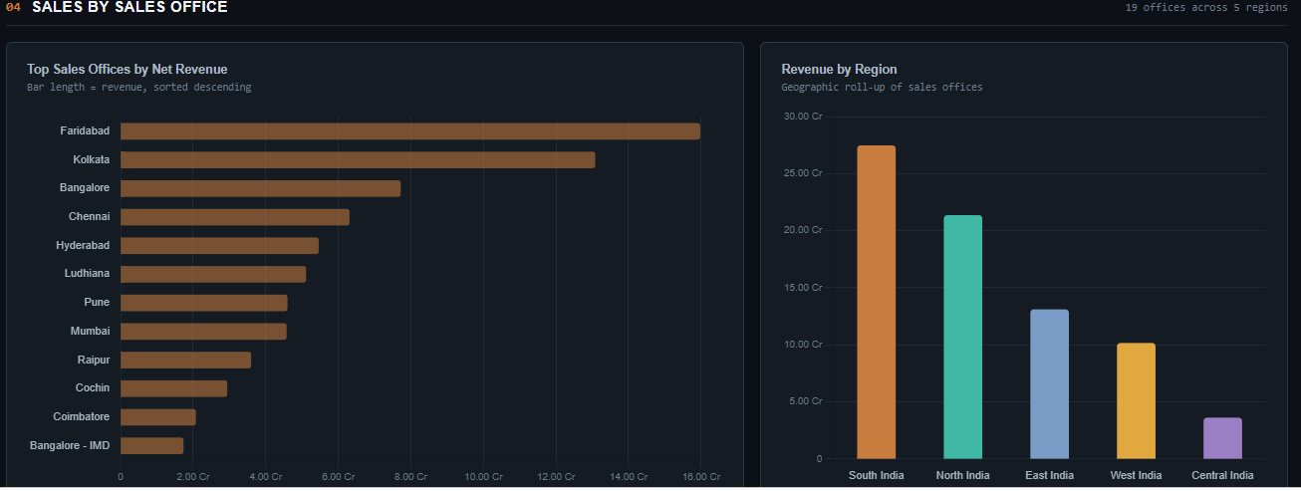

For Units, consider column Unit.
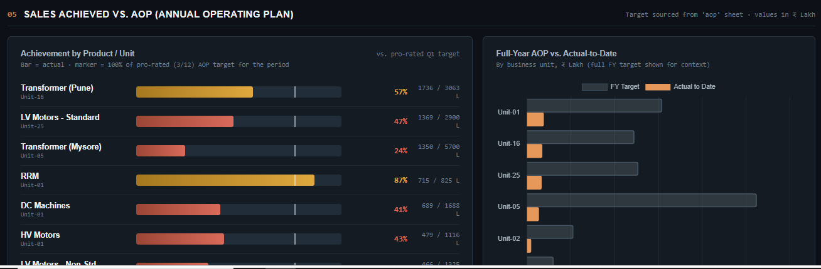

This Is Documentation of my dashboard, so kindly note all points and give me the proper working python flask code.

